

**Written exam on Advanced Course in Electrical Power Systems**

**03 June 2016 (9:30 – 13:30 hrs)**

**General Information**

* *The exam consists of 5 main questions and sub-questions.*
* *There are in total 7 pages.*
* *The weightage of each question is mentioned in the parenthesis.*
* *Please provide sufficient text description and reference to textbooks and equations so your method of solution is clear and easy to follow. Statements and results will only give credit if explained thoroughly*

**Helping Aids**

*All usual aids (like textbook, lecture presentation, programmable calculator or pc) are permitted.*

**Exercise 1 (20%)**

1. The energisation of a cable or overhead line results in waveforms whose shape and peak value depend on the energisation instant. Explain why the transient overvoltage peak value is maximal if the energisation happens when the source voltage is at a peak (either positive or negative). **(7%)**
2. The circuit below is energised at peak voltage. The waveform plot of the current through the circuit breaker (IS) is also given below. What is the value of the inductance in Henry? (Note: this is a simplified circuit, you assume that the capacitor can be charged instantaneously without transient) **(6%)**

**Data**

Source voltage (RMS): 7.07V

IS (peak): 54.6mA

Frequency: 50Hz

IS is inductive

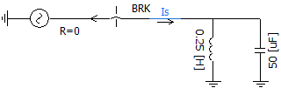

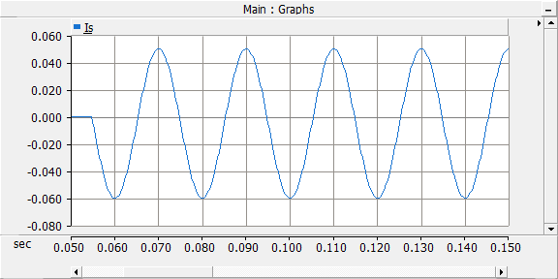

1. The shunt reactor (inductor) from the previous exercise is replaced by a new one with a reactance of 0.25H. The energisation instant is also changed and the waveform of the current in the circuit breaker is new and given below. What is the voltage at the energisation instant? **(7%)**

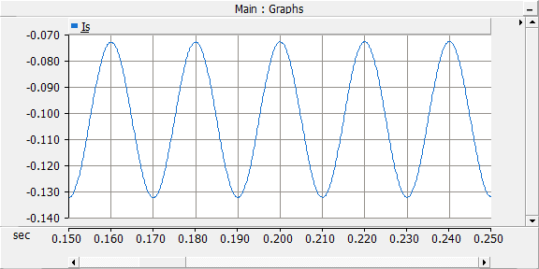

**Data**

Source voltage (RMS): 7.07V

IS (peaks): -73mA and -133mA

Frequency: 50Hz

**Exercise 2 (20%)**

a) The load flow data for a 4-bus power system are given in Table I and Table II. The reactive power limit of the generator connected to bus 2 is p.u. Determine the voltages at bus 2 and bus 3 at the end of the first iteration using Gauss-Siedel method. The line impedances are marked in per unit on a 100MVA base. Assume flat start () for those buses where voltages are not specified. Show your calculations.

(**12%)**

Table I Table II

|  |  |  |  |  |  |  |  |  |
| --- | --- | --- | --- | --- | --- | --- | --- | --- |
| Bus No. | P (MW) | Q (MW) | V | Bus Type |  | From Bus | To Bus | Impedance |
| 1 | - | - |  | Slack |  | 1 | 2 | 0.05+j0.15 |
| 2 | 50 | - |  | PV |  | 1 | 3 | 0.10+j0.30 |
| 3 | -100 | 50 | - | PQ |  | 1 | 4 | 0.20+j0.40 |
| 4 | 30 | -10 | - | PQ |  | 2 | 4 | 0.10+j0.30 |
|  |  |  |  |  |  | 3 | 4 | 0.05+j0.15 |

b) The incremental fuel costs of three generators in €/MWh are given as



with power P in MW and cost C in €/hr. A constant load of 450MW is supplied by the three generators. Neglect the transmission loss and determine

i) the economic sharing of load between the three generators in MW and

ii) the savings in €/day obtained from economic load sharing when compared to a case with equal load sharing between generators.

(**8%)**

**Exercise 3 (20%)**

1. Draw a circuit which may generate harmonics into the power system and discuss why the circuit generates harmonics. (6 %)
2. Draw a circuit which may be used as the active filter to the current harmonics and explain its working principles. (7 %)
3. Draw the bode plot of the passive filter and explain its working principles (you may assume your own parameters in the passive filter). (7 %)

**Exercise 4 (20%)**

A 60 kV outdoor substation with one single busbar is fed from a 150/60 kV transformer, see the single line diagram. A distance relay marked T is foreseen to act as primary protection for the 60 kV busbar. The photo shows an example of how the busbar arrangement could look in real life.



The three-phase short circuit power at 60 kV level is 500 MVA. The relay zones are set with forward direction towards the 60 kV busbar with the zone characteristics as shown in the R-X graph next page.

Zone time settings are: T1 =0,5 s, T2=0,8 s and T3=1,1 s

Assume a wind speed v = 10 m/s. The distance between each of the busbar phase conductors is 2 m.

a) Determine which of the zones of the set characteristic in the R-X graph will clear a two-phase fault at the busbar. Draw the fault impedance as a vector in the R-X diagram (must be handed in with exercise).

b) Comment on the result of a) and the use of the distance relay as primary busbar protection. Which type of protection would be better?



**Exercise 5 (20%)**

A HV factory manufactures 550 kV current transformers of a type like the one shown in the photo below

During their design consideration is put to avoiding corona discharges at the energized top. In order to model the top it can be assumed that it can be represented by an ideal sphere with radius R.

a) Develop, *step by step*, by means of the law of Gauss, the electric field distribution for concentric spheres with inner radius R1 and outer radius R2 (i.e. make the mathematical expression for E(R)). Compare with the textbook (Kuffel) result for this.

b) Develop, by means of the result from a) an expression for the maximum electric field strength Emax

It can be assumed that the maximum tolerable electric field strength in air is 12 kV/cm to avoid corona and that the energized top can be represented as a sphere assuming that the ground potential is far away (i.e. R2/R1 >>1).

c) Calculate minimum diameter Dmin (to avoid corona) for the top of the current transformer